1. **DATA RECONCILIATION**

Process measurements are inevitable by errors due to measurement, processing and transmission of the measured signal. The total error in a measurement, which is difference between the measured and true value of a variable, can be represented as the sum of contributions from 2 types of errors –

* 1. Random errors
  2. Gross errors

Errors measured can lead to significant deterioration in the performance of control systems. In some cases these errors can also drive process into an uneconomic or even unsafe operating system.

* Statistical Quality Control techniques can be used but they do not follow any process model. So in order for better results we use the technique of Data Reconciliation and Gross Error Detection. These techniques exploit relationships that are known to exist between the variables.
* DR technique is used to reduce random errors. The principal difference between DR and other techniques is that DR explicitly makes use of process model constraints and obtains estimates of process variables.

1. **SAMPLE CASE THAT WAS IMPLEMENTED**

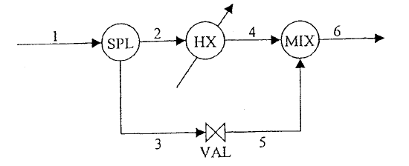

Fig 1 Heat Exchanger System

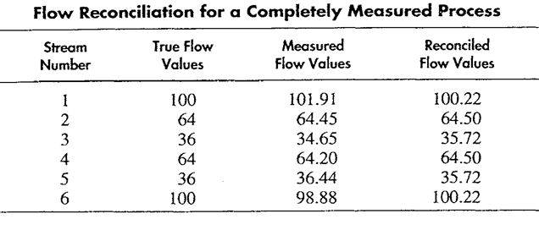

Table 1 Flow Reconciliation Values

**CONSTRAINTS:**

x1 - x2 – x3 = 0

x2 – x4 = 0

x3 – x5 = 0

x4 + x5 – x6 = 0

* It is a linear steady-state data reconciliation problem.
* There are various techniques which are available for optimization of functions of multiple variables subjected to equality constraints.
* The method best suited for our problem is Lagrange Multipliers Method.
* F(x1,x2… xn, λ) = (xi-yi)² + λ1(constraint 1) + λ2 (constraint 2) + ……. + λn (constraint n)
* Implementation of this was done in Python using Scipy libraries